Rancho Cucamonga, CA – Winnebago, MN - Greeneville, TN - Olive Branch, MS
Rancho Cucamonga, CA - Winnebago, MN - Greeneville, TN

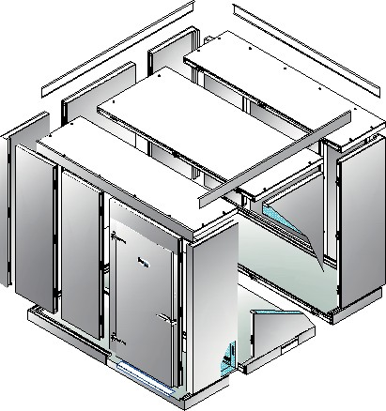

Installation Instructions
Wood Frame & Foam Rail
Rainy Road Holdings, Inc.
Rancho Cucamonga, CA - Winnebago, MN - Greeneville, TN
EVERIDGE
EVERIDGE, Inc.
Corporate -15600 37th Ave N Plymouth, MN 55446

Phone: 800-523-7337
Fax: 763-541-1563

Manufacturing Locations:
Rancho Cucamonga, CA - Winnebago, MN - Greeneville, TN

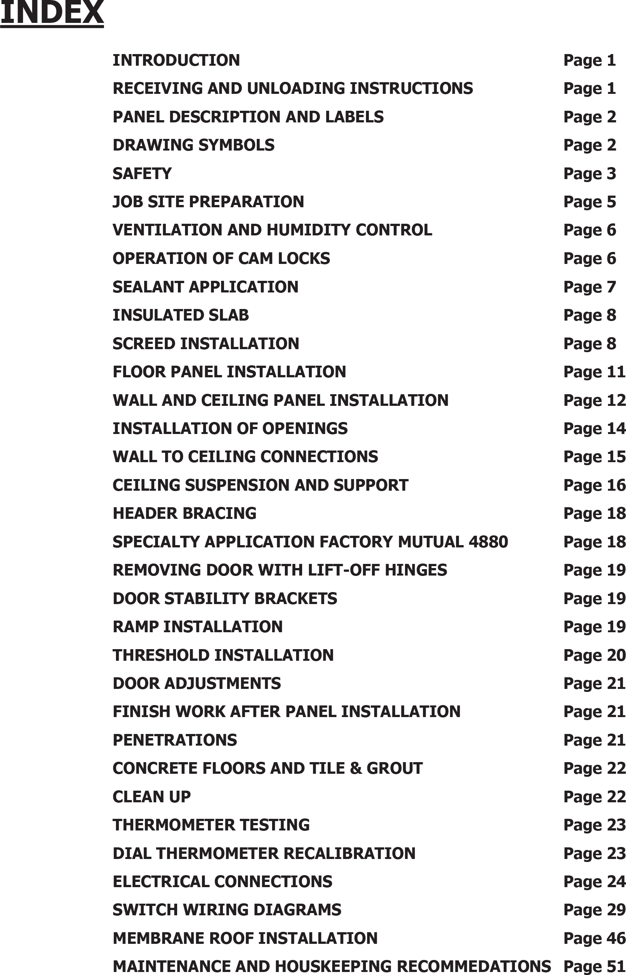
TENANCE AND HOUSEKEEPING RECOMMENDAT
1
1
2
3
4
6
7
7
8
9
9
12
13
15
16
17
19
19
20
20
20
21
22
22
22
23
23
24
24
25
30
48
53
IONS
MAIN

Introduction
As a company, we’re proud to say that this walk-in cooler or freezer was manufactured according to the standards that set us apart from all others. The following instructions are outlined to make the installation process operate safely and efficiently and it is important that they are thoroughly read and understood prior to installation. This manual provides basic instructions for the proper care, handling and installation of these
walk-in panels. All work should be performed by properly equipped and trained contractors.

Receiving, Unloading and Storage Instructions

Inspection of panels
Examine shipment for obvious damage. Inspect all panels carefully to ensure that no damage has occurred during the shipping process.
- In the event of damage, the carrier and receiver must report the product damage on the bill of lading and both parties must sign.
- Immediately file a claim of damaged goods with the shipping company.
- Immediately notify the panel manufacturer Service/Installation Team by sending a copy of the marked up and signed bill of lading and pictures to the attention: Freight Claims. (Fax: 763-541- 1563)
- Receiver must notify Manufacturer of any concealed product damage within 10 days of receipt of shipment. Any documentation, pictures and the original packaging material of the damaged item must be retained pending disposition of the damaged item.
Check the Delivery Receipt for the number of pieces that made up the shipment and make sure that the number of pallets, boxes or crates agrees with that number. Each piece should be clearly marked with the same order number followed by a dash.

Inspection of Panel Installation Drawing
A quick review of the panel layout will serve as guide for unloading panels. The hardware box contains the panel Installation drawing and each pallet will contain a packing list for all panels included on that pallet.
- For missing or replacement parts, contact the Manufacturer Customer Service Department immediately with the order number listed on the shipment.
- Select corners, t-walls, jambs, headers, sills, etc. and separate from standard wall panels such as 47” and 23”. This will reduce handling, save labor and reduce damage.

Storage of Panels On-Site
Panels must be stored indoors and protected from the elements prior to installation.

Indoor walk-in(s) must be installed in an environmentally controlled space for optimal performance. Relative humidity should be between 50% - 60%, maintaining a low dew point.

1

Panel Description and Labels

Each panel is labeled to aid in identification and proper placement.
Customer Name Box Description
Panel identifier as shown on drawings
Exterior Finish Interior Finish
Arrow points to exterior
Product Brand
CUSTOMER NAME
UNIT DESCRIPTION
#4
Interior
Exterior
SW
SG
162-097631-01
WIDTH
23
HEIGHT
216
THICKNESS
5
Job Number
Panel width Panel height Panel thickness
Inspection sign off
FINAL INSPECTION
FOAM INS
ASSEMBLED BY

FIG. 1 – PANEL IDENTIFICATION LABEL

NSF Packaged Product Only option available for applications where food product is stored in original packaging only with no open food processing.

2

Drawing Symbols
Panel Installer shall review each drawing and become familiar with the symbols (see below) and panel layout for each compartment. Drawings for each walk-in are included in the hardware box. Panels are built with a tongue and groove system that integrates cam-locks, a fastening mechanism using a cam action hook that is turned to securely engage the pin for easy installation.

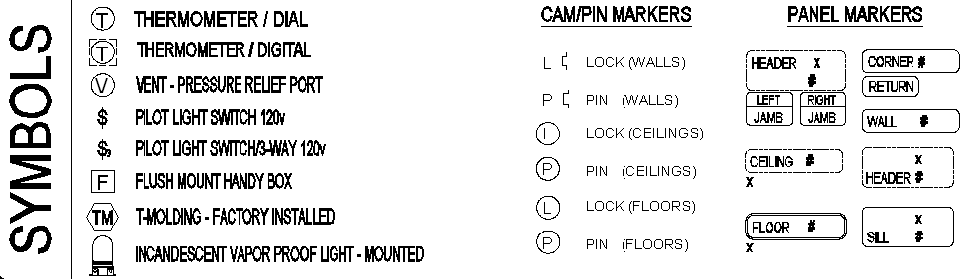

3

Safety
Please follow these safety guidelines when installing walk-ins:
- Required Personal Protective Equipment (PPE) for walk-in installation:
  - Hard Hats
  - Safety shoes per OSHA guidelines.
  - Safety Glasses
  - Protective Gloves
  - Protective Clothing- long pants and long sleeve shirts should be worn.
  - Safety Harnesses must be worn when working on elevated surfaces.
- A certified electrician must do all electrical wiring.
- Keep work-site free and clear of debris.
- Use proper lifting techniques and ASK for HELP when needed!
- USE COMMON SENSE; BE AWARE OF YOUR SURROUNDINGS.

Each job site is different, there may be other safety items required by the General Contractor. Always check with the General Contractor to make sure that you comply with all job-site rules.

Safety and Other Symbols in this Installation Guide

The following safety symbols are used throughout the Installation Guide to highlight safety information. Pay close attention to safety information.

The Warning Symbol Alerts you to potential personal injury situation. Read the warning and work carefully.
The caution symbol alerts you to a situation in which property damage could be caused, either by the panel materials, or property in the installation area. Read the caution and work carefully.

The following symbols are used throughout the Installation Guide to provide additional information that you may find helpful.

The freezer symbol precedes extra information which is relevant only to freezer installations.
The tip symbol precedes information that may make the installation process easier for you.
Tips are optional. Read the tip and decide if you want to apply it.
The Warranty Symbol precedes information related to required action to assure limited warranty is upheld.

Read These General Safety Notices Before Beginning Any Installation Work

Panels are heavy and require at least two people to move them safely. Lift with your legs, not your back.

To avoid injury while assembling the walk- in, wear protective eyewear, hard hat and steel- toed boots.

4

Safety (continued)
Until the walls are made stable by constructing the corners, support extended wall lengths by bracing them from both inside and outside.
The Installation Guide should be used as a general reference only. Follow your blueprint for specific information on your installation.

Tools Needed
You will need to purchase (when not supplied with walk-in) and apply sealant in the seams between panels, see page 7. Follow all of the safety precautions on the sealant package.

WARNING! – THE HEATER CABLE AND HEATED AIR VENT MUST NOT BE ENERGIZED PRIOR TO THE REFRIGERATION STARTUP. FAILURE TO DO SO MAY RESULT IN PREMATURE HEATER BURNOUT AND VOID THE HEATER WARRANTIES.

- 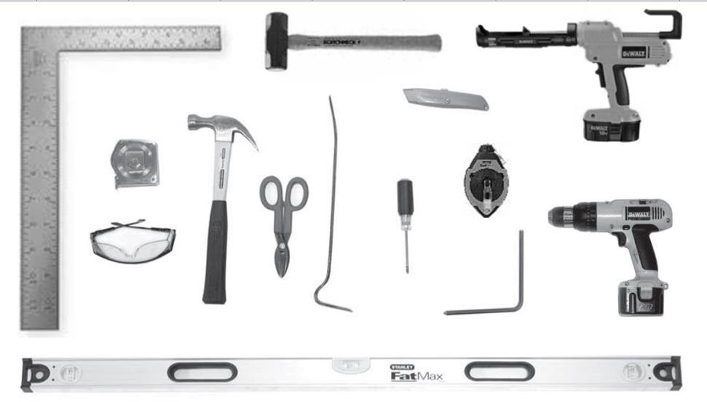Level
- Chalk line
- Caulk gun
- Tape measure
- Safety glasses
- Hammer
- Metal snips
- Pry bar
- Allen wrench
- Utility knife
- Square
- Drill driver
- Sledgehammer/Mall
- Phillips screwdriver

WALK-IN MUST BE INSTALLED ON A LEVEL SURFACE!
• Check the stability of the floor.
o All walk-ins must be placed on a stable foundation. Movement of the floor under the walk-in because of soil conditions, freezing / thawing, or other reasons can cause damage to the walk-in. Such damage is not covered by our warranty.
  - Check to see if floor is level. *A LEVEL FLOOR IS CRITICAL*
    - If the floor is not level, shims (not supplied) must be used as required under the wall panel, screed or panel floor to make the walls level. In some cases, sand leveling may be required, particularly for larger installations with uneven building floors.
  - Check overhead area where walk-in is to be installed for any obstructions.
    - Any obstruction should be corrected prior to starting.
5

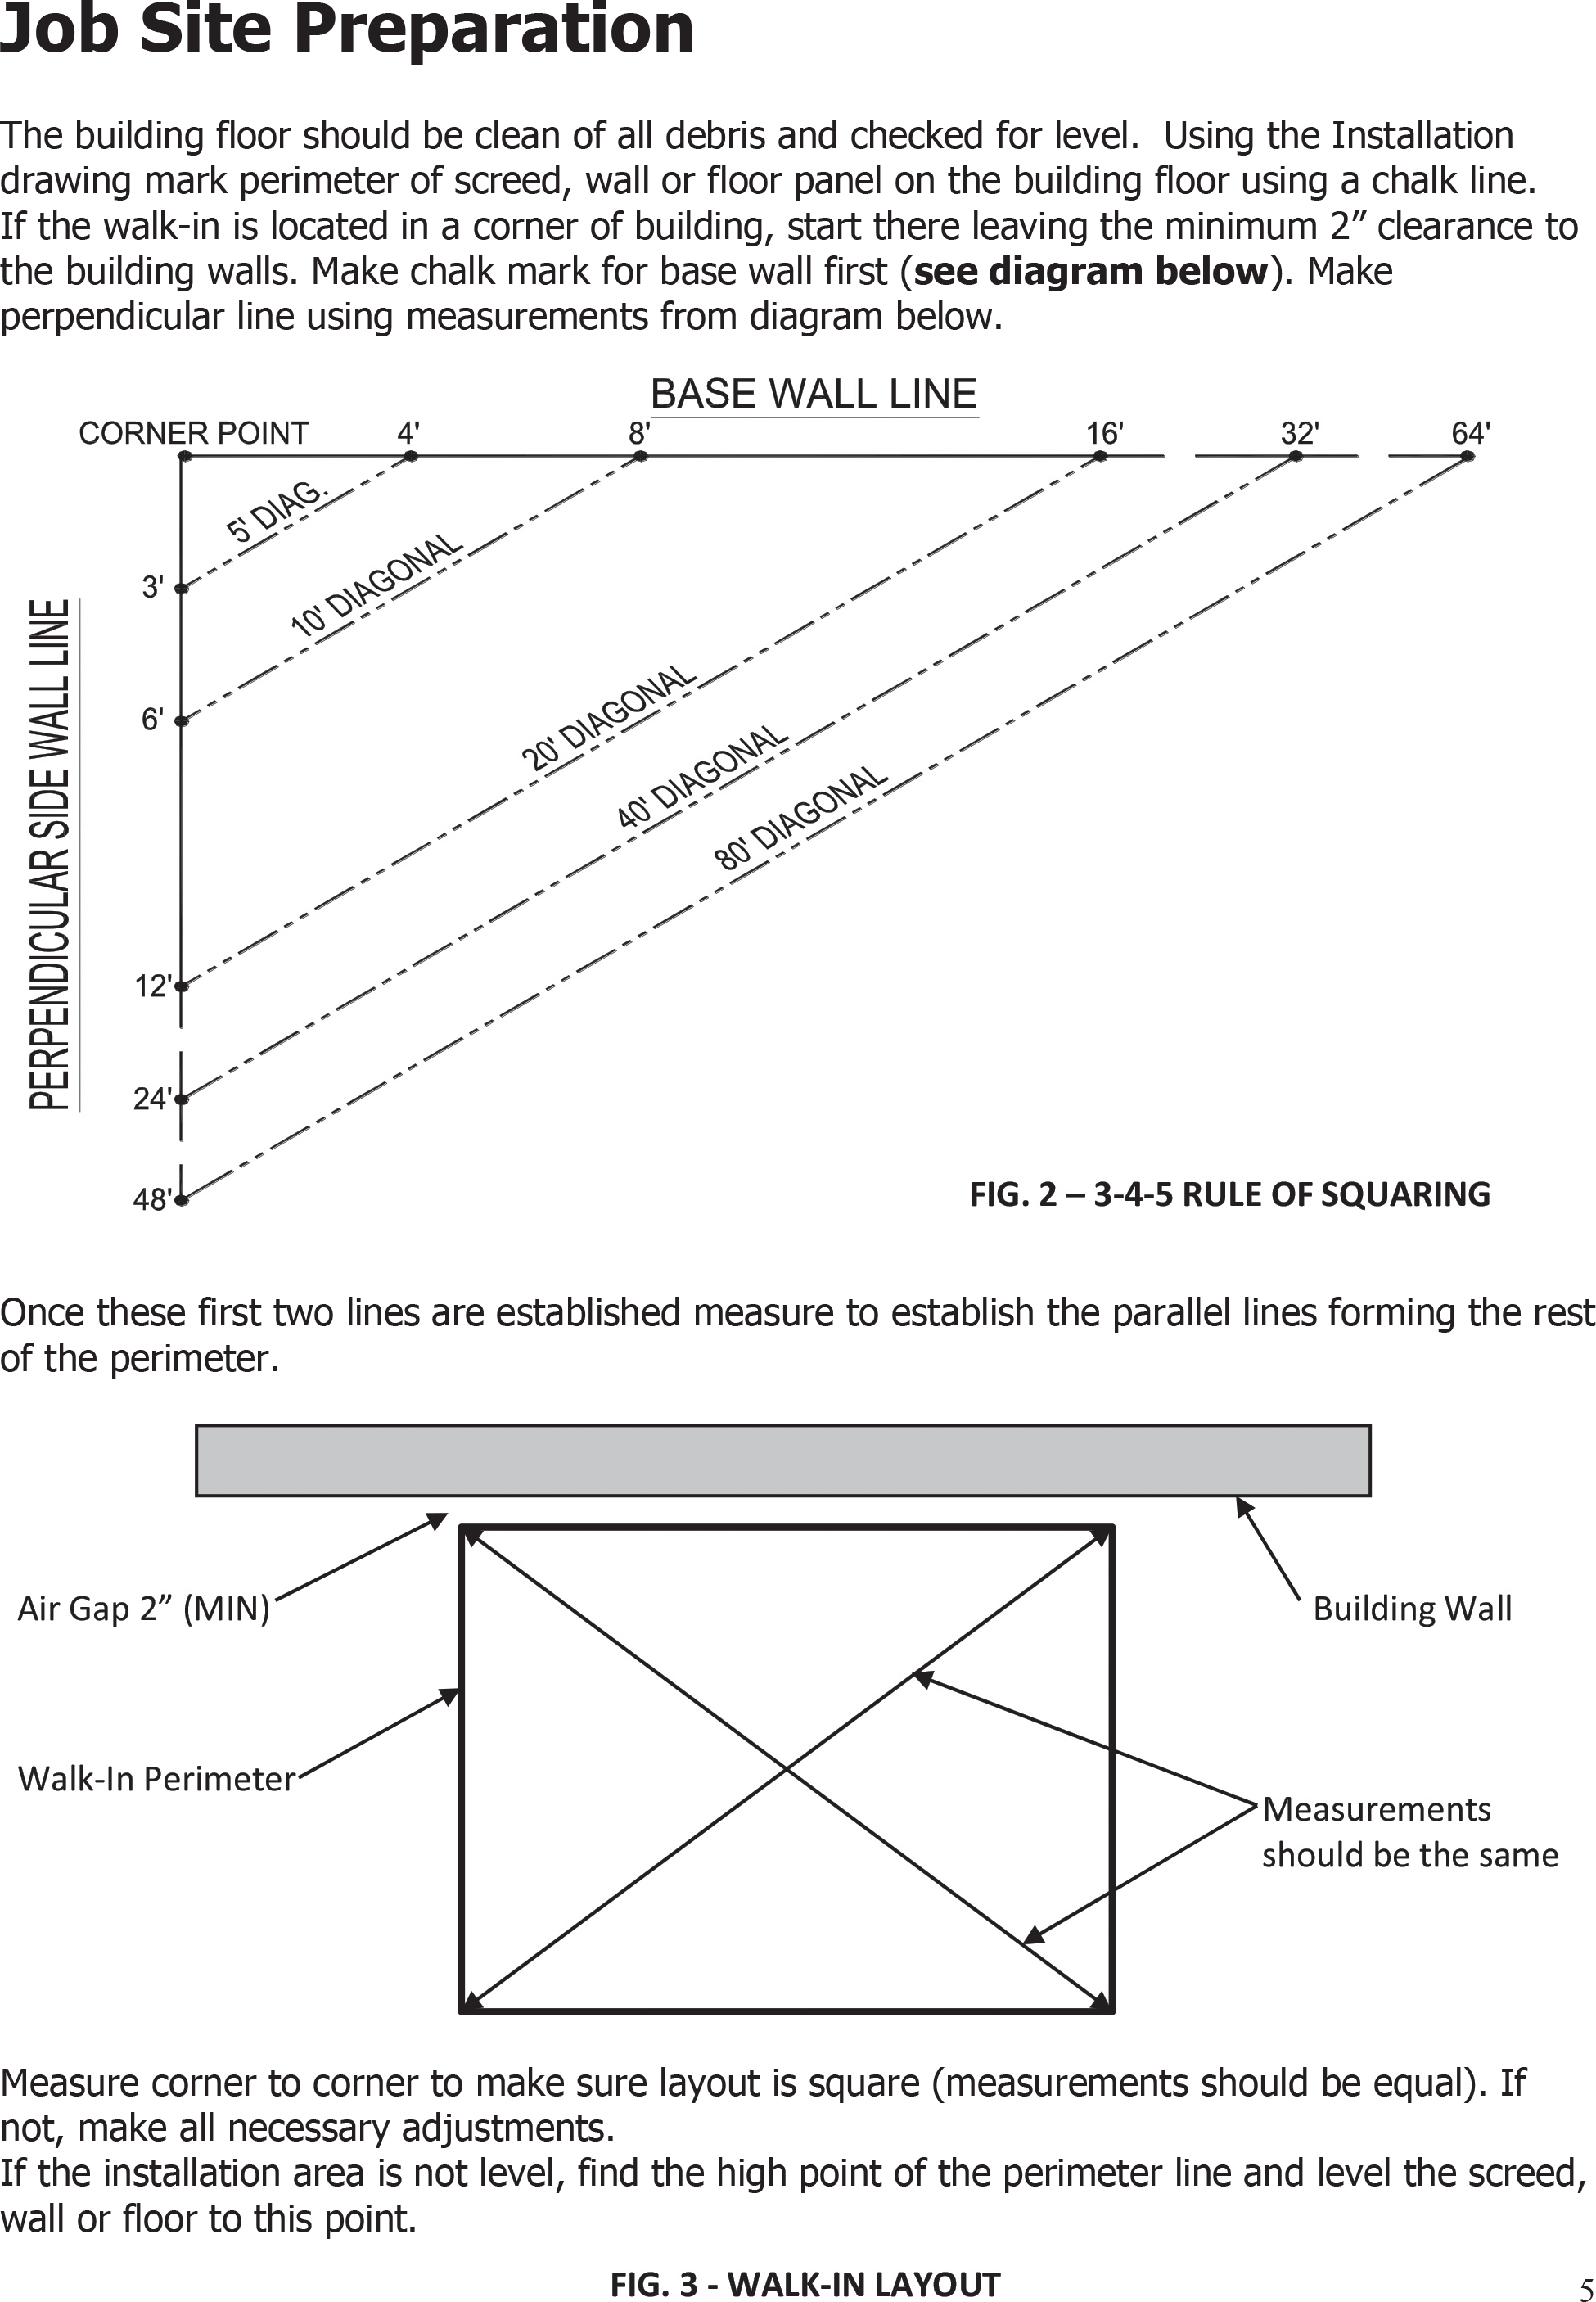

6

Ventilation and Humidity Control
For indoor applications, it is the responsibility of the installer and the owner to make sure the walk-in has proper ventilation and humidity control.
Maintaining a minimum space of 2” for air movement is critical for wall and ceiling surfaces.
If inside conditions reach the dew point on outside surfaces of the walk-in, condensation will occur and the resulting damage would NOT be covered under panel warranty.
The sheet metal panel may be susceptible to staining due to excessive moisture created by hydration of concrete-type materials. Therefore, it is absolutely necessary that each room be properly ventilated. Also, please note that special precautions must be taken when using muriatic acid due to the effects of hydrochloric acid fumes have on different types of metal.
Any contractor using this cold storage room for storage of tools or materials without written permission from the owner does so at their own risk and is subject to property damage liability.

Operating Cam Locks
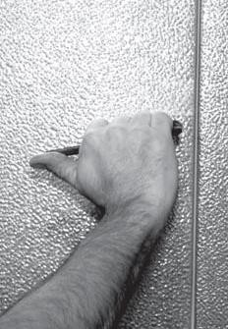The panels are held together with a cam-action hook and pin assembly. The cam lock should never be used to pull the panels together. The panels should be set in place making sure the top of the panels are level before the cam is locked.
- Insert the hex wrench (packed in the hardware box) through the access hole in the interior panel metal into the hex opening of the cam-lock. Turn wrench in a counterclockwise direction to ensure that the lock is fully unlatched.

- Push the sections tightly together and turn the wrench 1/4 turn in a clockwise direction. This will engage the locking arm (hook) over the pin in the lock housing.

- Continue turning the wrench to a full stop (approximately 3/4 of a complete turn from the unlatched position) to complete the locking operation.

The cam-lock on some panels will have to be turned counterclockwise to activate the locking cam. These latches will be designated by a "TURN" sticker

The tongue side of the wall panel and cam lock holes are on the right when viewed from the inside of the walk-in. The exact location of the tongue and groove for the ceiling and floor panels will be shown on the Installation drawing

7

Sealant Application
On all freezer units (units that have an interior temperature equal to or less than 32°F/0°C) a ⅜” bead of non-drying Butyl
sealant as shown in the detail must be applied between all floor to floor, wall to floor, wall to wall, wall to ceiling, and ceiling to ceiling joints. This needs to be a continuous bead of butyl that extends the full length of each panel and around each corner to meet with the adjacent edge. Butyl should always be applied on the warm side of the panel unless specifically required on both sides per drawing details. This will guarantee that the panels will be sealed and prevent any air leaks that could form ice and damage the panels when units are brought down to operating temperature.

FREEZER PANEL FLOOR, TOP OR WALL

NON-DRYING BUTYL SEALANT (3/8” BEAD)

On all cooler units (units that have an internal temperature equal to or above 33°F/.9°C) a ⅜” bead of non-drying Butyl sealant must be applied at the wall to concrete floor
WARM SIDE
intersection. This needs to be a continuous bead of butyl. Butyl should always be applied on the warm side of the panel unless specifically required on both sides per drawing details. This will guarantee that the panels will be sealed and prevent any air leaks that could form condensation and damage the panels when units are brought down to operating temperature.

Panel joints are vapor tight not waterproof, therefore, all walk-ins installed outdoors will have recessed gasket on the outdoor side of panel joints to allow space for the installer to apply a sealant before the panels are assembled. Use a high quality sealant such as Xtra Bond 9500 or equal. An annual inspection for gaps in the sealant is required for the life of the warranty
FIG.4 - FREEZER PANEL

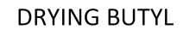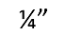FIG. 5 - COOLER PANEL TO CONCRETE FLOOR

COOLER PANEL WALL TO CONCRETE FLOOR

NON-DRYING BUTYL SEALANT (3/8” BEAD)
WARM SIDE

FIG. 6 – SEALANT APPLICATION OUTDOOR UNITS

Silicone sealant is used as an aesthetic application, as well as a moisture barrier. Silicone shall be applied in ¼” continuous beads to the interior and exterior of wall to non-panel floor joints and at the wall to ceiling joint on the interior of the walk-in. Silicone should be applied to a surface that is clean of debris and should be tooled to leave a clean, continuous edge. Proper tooling will also insure that the silicone has adhered to the surface properly and has filled any gaps that may collect moisture or debris. Also, drawing specifications will indicate silicone application on added trim, seismic angle, or accessory products.

APPLY SILICONE TO INTERIOR WALL TO CEILING PANEL INTERSECTION

APPLY SILICONE TO BOTH SIDES OF WALL TO CONCRETE FLOOR
FIG. 7 - SILICONE SEALANT APPLICATION 8
7

Insulated Slab
All freezers require insulated floor panels or an insulated slab. When an insulated slab is used, be sure the breaker strip is exposed and not covered by concrete or grout. The vapor barrier should be visible on the exterior of the breaker strip.

VAPOR BARRIER MUST BE ON THE WARM SIDE – UNDER THE INSULATION AND ON EXTERIOR OF BREAKER STRIP
WOOD BREAKER STRIP FLUSH WITH CONCRETE
WARE SLAB

INSULATION R-28 (MIN.)

FIG. 8 – INSULATED SLAB

The breaker strip and vapor barrier must be visible. If the breaker strip and vapor barrier are not visible DO NOT INSTALL THE FREEZER. Notify the General Contractor and Rainy Road Holdings, Inc. Service/Install Team immediately.

Screed Installation
There are many styles of screeds. The type of screed used on your walk-in will be identified on the Installation drawing. The following details are for information only, consult the Installation drawing for details specific to your walk-in.

Be sure you have the correct screed before fastening to floor.

Place the screed on the floor using the chalk lines as guides (See Fig. 2 and 3). Screed type is described in the Installation drawings.

- A thermal separation (breaker strip) is required at all freezers to separate the interior concrete from the exterior concrete. The interior freezer concrete floor must be insulated and completely isolated. The screed is to be centered over the breaker strip.

- Apply a 3/8” bead of non-drying butyl sealant as shown in Fig. 9, 10 and 11.

Start at a back corner and fasten screed in place for two adjoining walls. Fasten screed as shown on Installation drawings with fasteners provided.

- To insure proper fit, do not install screed for remaining walls until wall panels for the first two walls are assembled.
9

Screed Installation (continued)

VINYL CHANNEL SCREED

VINYL CHANNEL SCREEDS ARE SHIPPED IN 10 FOOT LENGTHS AND ARE FIELD CUT, NOTCHED AND MITERED TO FIT WALK-IN DIMENSIONS. FASTEN AT 24” OC WITH 8d NAIL TO WOOD BREAKER STRIP OR ¼” X 1
½” DRIVE PINS INTO CONCRETE.

WALL PANEL
APPLY SILICONE AT TOP AND BOTTOM EDGES BOTH SIDES
SCREED IS NSF COVED

APPLY 3/8” BEAD NON-DRYING BUTYL SEALANT AT WARM SIDE 1 BEAD UNDER SCREED AND
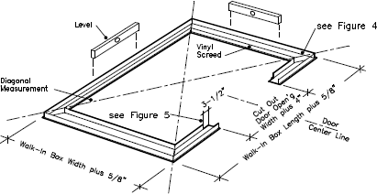1 BEAD INSIDE SCREED
INSULATED SLAB REQUIRED AT FREEZERS

Strike chalk lines on the floor, using exterior walk-in box dimensions plus 5/8”. Lay a 3/8” bead of butyl around inside of chalk line. Set screed around chalk line, leveling and shim as required. Locate door section from installation drawings, cut out screed – door opening plus 4”, and notch inside of screed back 3 ½” at each side to receive door anchors. Fasten to floor.
NOTE: Vinyl screed must be square and level

Notch out piece A and taper piece B to fit into notch at wall intersections. Miter the vinyl screed at 46° to insure proper fit. The inside corners need to be sealed after panels are set place and locked together.
See detail below

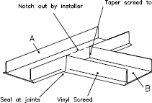
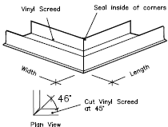FIG. 9 – VINYL CHANNEL SCREED 10
in
9

Screed Installation (continued)
CONCEALED ALLIGNMENT STRIP SCREED

CONCEALED ALLIGNMENT STRIP SCREEDS ARE SHIPPED IN 8 FOOT LENGTHS AND ARE FIELD CUT TO FIT WALK-IN DIMENSIONS. FASTEN AT 24” OC WITH 8d NAIL TO WOOD BREAKER STRIP OR ¼” X 1 ½” DRIVE PINS INTO CONCRETE.
WALL PANEL
APPLY SILICONE AT BOTH SIDES OF WALL TO CONCRETE FLOOR
INSTALL NSF COVED BASE TRIM

APPLY 3/8” BEAD NON-DRYING BUTYL SEALANT AT WARM SIDE
INSULATED SLAB REQUIRED AT FREEZERS

FIG. 10 – CONCEALED ALLIGNMENT STRIP

ANGLE SCREED

ANGLE SCREEDS ARE SHIPPED IN 10 FOOT LENGTHS AND ARE FIELD CUT TO FIT WALK-IN DIMENSIONS. FASTEN AT 24” OC WITH
¼” X 1 ½” DRIVE PINS INTO CONCRETE AND
¼-14 X 1 ½” HEX WASHER HEAD TEK SCREWS

FOR NSF, TURN ANGLE UNDER WALL AND ADD COVED TRIM.

APPLY 3/8” BEAD NON-DRYING BUTYL SEALANT AT WARM SIDE
INSULATED SLAB REQUIRED AT FREEZERS

FIG. 11 – ANGLE SCREED

11

Floor Panel Installation (if included)

- Mark and level floor according to Job Site Preparation on page 5.
- Locate the highest point in the marked area and level to this point using shims located at 12” on center in all directions.

IMPORTANT! The floor must be perfectly level! If not, the wall panels will not be square and plumb, the panel joints will not seal properly and the doors will not operate correctly.

- Layout floor panels in the correct sequence as shown on the Installation drawings making sure they are level. Panels are labeled with numbers corresponding to those on the Installation drawing.
- See page 7 before locking any freezer panels together.
- Lock floor panels together making sure edges are flush and square.
- Install the remainder of the floor panels. When all of the floor panels are installed and leveled perfectly, check the cam locks for full and complete locking.

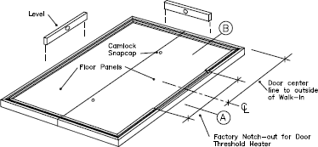

FIG. 12 - FLOOR ASSEMBLY – EXAMPLE ONLY

12

Wall and Ceiling Panel Installation
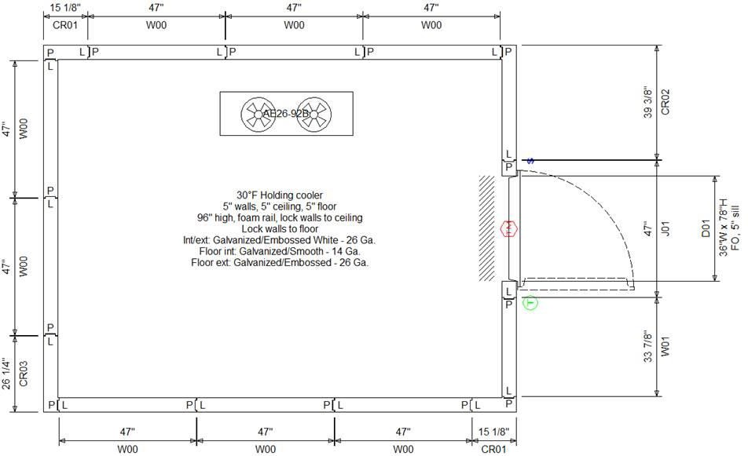
Fig. 13 – INSTALLATION DRAWING – EXAMPLE ONLY

It is important that you review the Installation drawings before starting the panel installation. Review figures 14 and 15 below showing the correct and the incorrect method of installation.

Panels are level and plumb Panels are not level and plumb

Wall Panels
Wall panels

FIG. 14 - CORRECT INSTALLATION FIG. 15 - INCORRECT INSTALLATION

Before completing the installation of all the walls you will need to begin installing the ceiling panels. The ceiling panels will lock together in the same manner as the wall panels and care must be taken when aligning the ceiling panels to ensure a vapor tight seal. Remember to review the Installation drawings to verify how the ceiling panels will be secured to the walls – lock down, lag down or inside tie down. Also be sure that butyl has been applied properly in all locations (see page 7). If the ceilings are to be lagged down be sure not to over tighten the lags and cause damage to the exterior metal of the ceiling panels. Over tightening could cause the panel to lose its structural integrity.
13

Wall and Ceiling Panel Installation (cont’d)
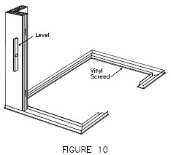Each panel is labeled to aid in identification and proper placement, see page 2. The panel numbers are found on the labels and correspond with number on the Installation drawing. See Installation drawing for correct panel placement and sequence.

Fig. 16 – START WITH A CORNER PANEL
The walk-in wall panel erection should begin with the setting of a rear wall corner panel after the screed or floor panels are set in place.
NOTE: Wall panels must be plumb!

See page 7 before locking any freezer panels together.

Begin by cam locking corner panel and one wall panel together.

All panels have factory installed panel gaskets. If panel gaskets are damaged or torn they must be repaired prior to installation.

This is very important so that the panel joints are vapor tight after installation.

‘T’ panels are used to connect a common wall that separates two walk-ins. Install ‘T’ panel and complete common wall before installing the opposite ‘T’ panel. Install wall panels in both directions.

Be sure panel edges are flush across the top and at seams. See page 12.

Once the third wall is started, begin top panel installation starting with an end ceiling. Install ceiling panels as wall panels are installed. See Installation drawing for correct ceiling panel placement, sequence and fastening to wall panels. When installing ceiling panels, lock ceiling panels together first then lag bolt or cam lock wall panels to ceiling panels.

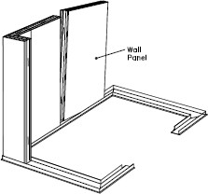

Fig. 17 – CAM LOCK WALL PANELS TO CORNER PANEL
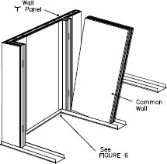

Fig. 18 – INSTALL WALL PANELS IN BOTH DIRECTIONS

14

Installation of Openings
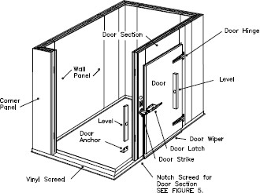
Fig. 19 – INSTALLATION OF DOOR SECTION – OVERLAP DOOR SHOWN – EXAMPLE ONLY
WARNING! The door and door section must be horizontally and vertically aligned to ensure proper sealing or the door before proceeding with panel installation. Make sure all openings are square, plumb and match the dimensions shown on the Installation drawings.
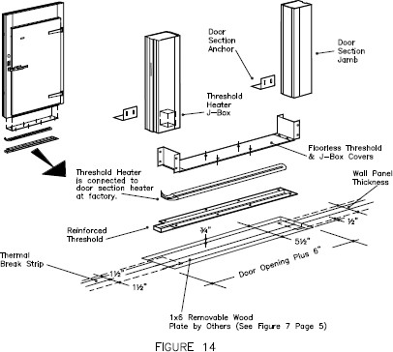
1
Fig. 20 – INSTALLATION OF DOOR SECTION
OVERLAP DOOR WITH SEPARATE HEATED THRESHOLD SHOWN – EXAMPLE ONLY
15

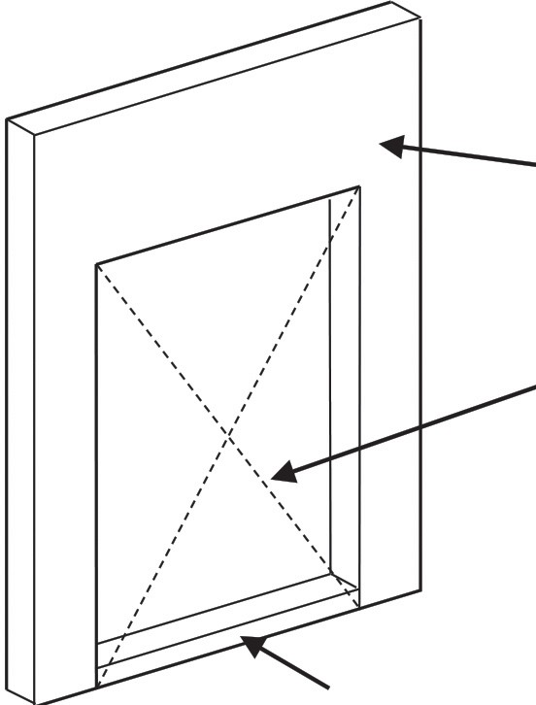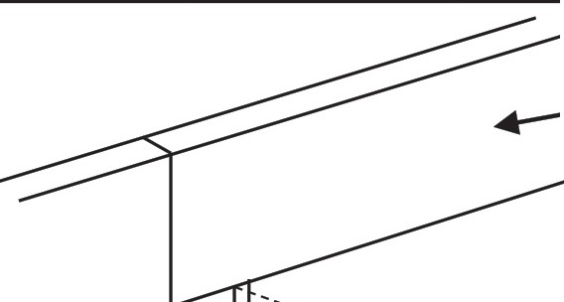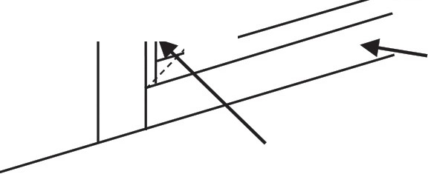Installation of Openings (continued)

DOOR SECTION

DIAGONAL MEASUREMENT METHOD

BLOCKING CUT TO SIZE OF DOOR OPENING WIDTH AS SHOWN ON INSTALLATION DRAWING
...-HEADER PANEL
--:;..:....
/ / _A. - ;;t; MENT
SILL PANEL
BLOCKING CUT TO SIZE OF OPENING HEIGHT AS SHOWN
ON INSTALLATION DRAWING

Fig. 21 - DOOR SECTION Fig. 22 - GLASS DOOR OR WINDOW OPENING

Use a spacer to ensure the bottom of the door opening is the same dimension as the top. Also use the diagonal measurement method to check that the opening is properly aligned and square. Install the door anchor angle at interior on both sides of opening. Fasten the angle to the interior of the door section jamb and floor panel or the building floor. The door must be dosed and latched before the door angle anchor is fastened to the floor.

When installing openings for reach-in doors or windovvs, use the same process but ensure that the height of the opening is correct and matches the dimensions on the Installation drawing.

Wall to Ceiling Connections

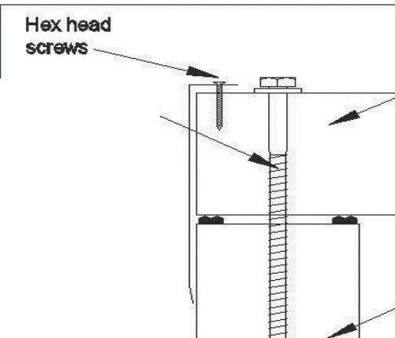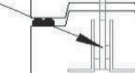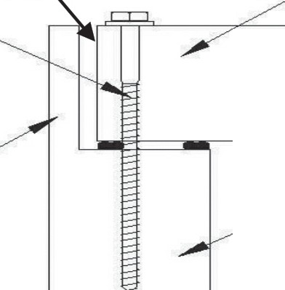lnsuated
3/8" 1ag bolt & wam er
Field inslaled
1rimcap
Insulated
ceiling panel
ca m-look walls
to e<1lllng
Insulated
wall panel
Fill with
spray foam
Insulated ceiling panel
3/8"1agbolt &washer
Concealed wall top
ll'ISUated wall panel
cellng panel

lnsula11ed
walpanel

FIG. 23 - LAG DOWN CEILINGS

Fasten ceilings to walls with 3/8" lag bolts and washers at 23" on center.

Field install trim cap with #8 X
¾"screws at 24" on center
FIG. 24 - LOCK DOWN CEILINGS

Cam lock walls to ceilings
FIG. 25 - FASCIA CEILINGS

Fasten ceilings to walls with 3/8" lag bolts and washers at 23" on center. Fill gap between ceilings and fascia with spray foam

16

Ceiling Suspension & Support
Ceilings may be supported by all-thread rod or wire suspension systems. The following details show the suspension system installation. See the Installation drawing for the type and location of your suspension system hanger brackets.
FIG. 26 WIRE SUSPENSION
WOOD FRAME AND FOAM FRAME
TOP PANEL
FASTEN WITH 6-8d
COATED NAILS
CAM-ACTION
FASTENER
4 STRANDS OF 12
GA GALVANIZED WIRE TO TOP CORD OF BAR JOIST

17
16
FIG. 27 ALL-THREAD SUSPENSION
WOOD FRAME AND FOAM FRAME
FASTEN WITH 6-8d
COATED NAILS

TOP PANEL
CAM-ACTION
FASTENER
3/8” ALL-THREAD
FASTENING TO OVERHEAD STRUCTURE IS BY OTHERS

NUT AND WASHER ABOVE AND BELOW BRACKET

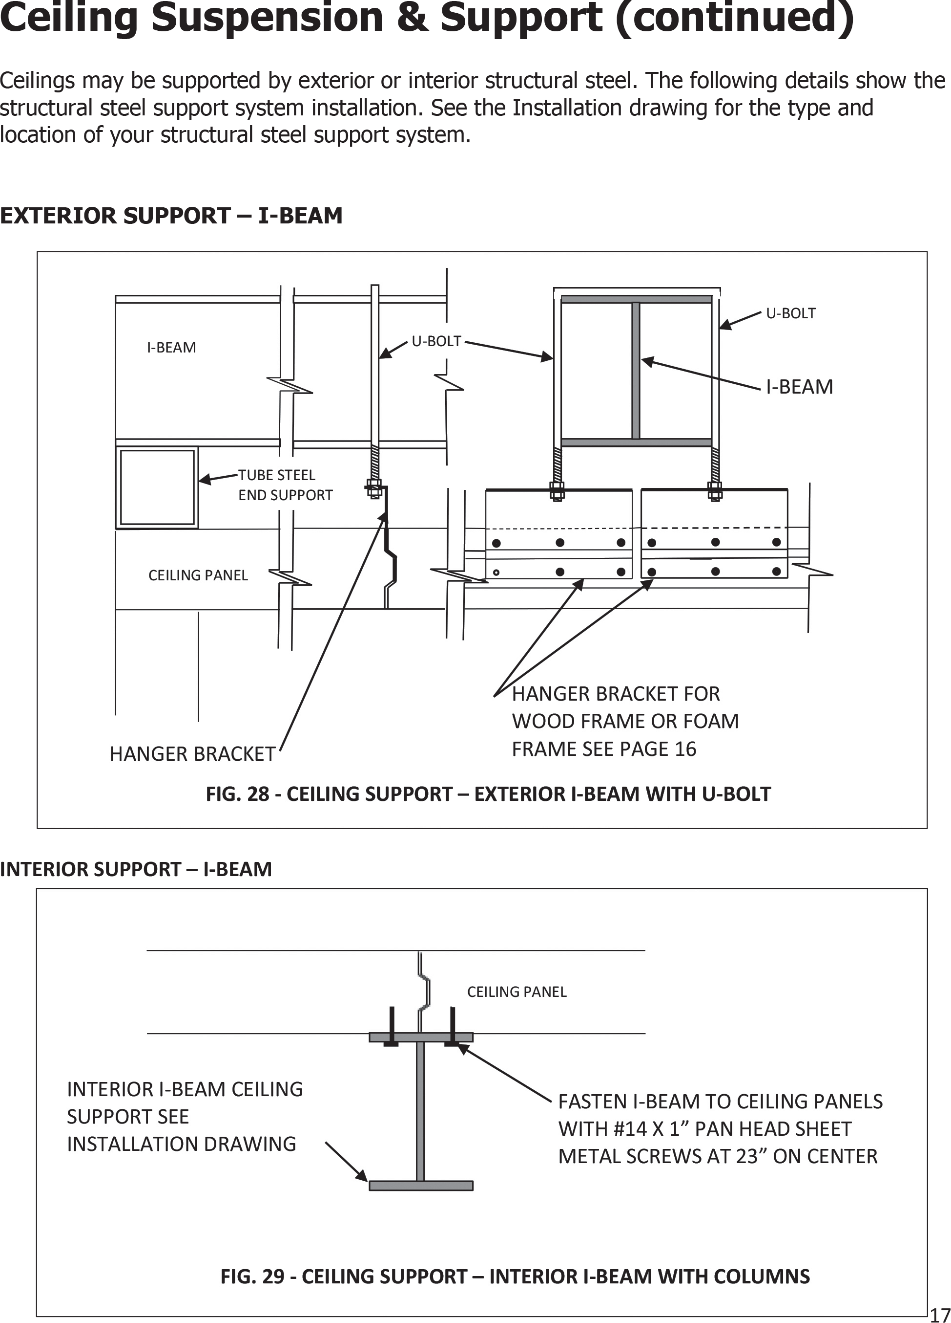

18

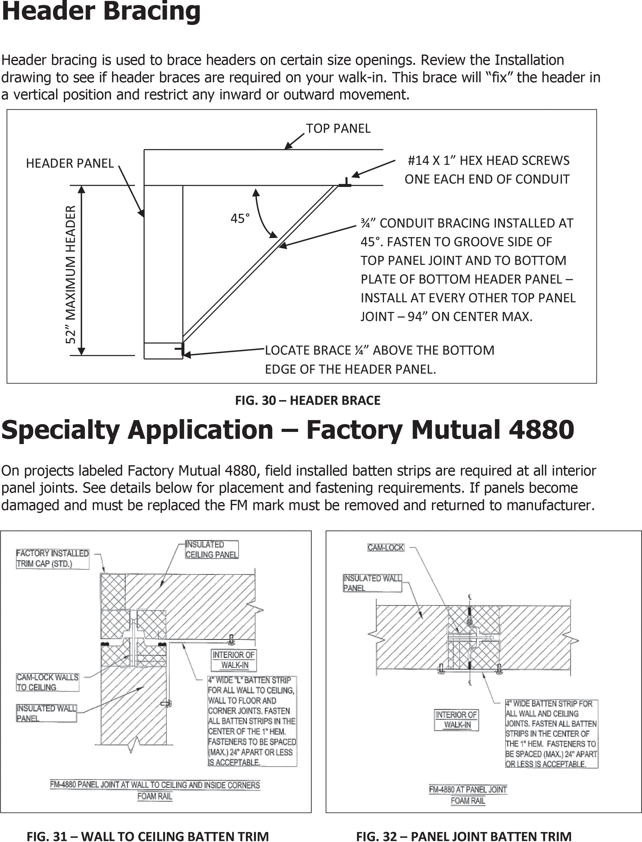

19

Removing Doors with Lift-Off Hinges
Doors are factory installed on the door section. If the door has lift-off hinges and is to be removed, the following instructions must be followed:
  - Open door to the dwell position – approximately 120°.
  - Put a mark on the floor to indicate the position.
  - Lift door off the hinges.
  - To replace the door, line up the door with the mark on the floor.
  - Place hex hole in hinge straps over hex rods on hinge butt and lower door.

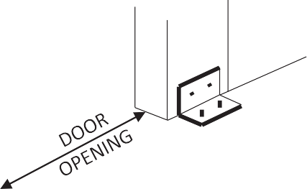Door Stability Brackets
DOOR SECTION
DOOR STABILITY
BRACKET
FIG. 33 – DOOR STABILITY BRACKET
Install 2” X 2” X 4” door stability bracket on each interior side of door section with 2-#14 X 2” Pan Head screws and to building floor with 2- 1/4” X 1 ¼” drive pins or to panel floor with 2-#14 X 2” Pan Head screws.

Ramp Installation (if included)

INTERIOR RAMP INSTALLATION

APPLY BUTYL AT ALL INTERSECTIONS OF RAMP OPENING

RAMP COVER WITH NSF COVE. APPLY SEALANT TO ALL RAMP EDGES
Interior ramps are factory installed in floor panels. When this is not possible due to ramp location, the ramp must be field installed. Apply sealant at all intersections of ramp opening and concrete floor. Install ramp and ramp cover and fasten in place. Apply sealant to all ramp edges.
RAMP

RAMP COVER WITH NSF COVE APPLY SEALANT TO ALL RAMP EDGES

FIG. 34 – INTERIOR RAMP INSTALLATION

EXTERIOR RAMP INSTALLATION

Exterior ramps are shipped loose for field installation. Fasten to concrete floor using 2” X 2” – 4” angle and 2-¼” X 1 ¼” drive pins into concrete and 2- #14 X 2” Pan Head screws into ramp.

FIG. 35 – EXTERIOR RAMP INSTALLATION
19
20

Threshold Installation (if included)
Cooler door openings typically do not require thresholds. However, cooler openings will require a threshold to cover the breaker strip if an insulated slab with breaker strip has been provided or if the cooler has been designed with an insulated panel floor. If this is the case, install the unheated threshold as detailed below for freezers.

Be sure to seal complete perimeter of threshold.

THRESHOLDS AT FREEZER DOORS ON CONCRETE FLOOR
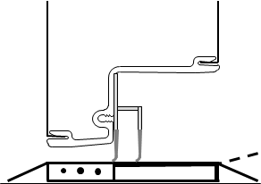
THRESHOLD TURNED UP
WITH INTERIOR RAMP
FASTEN THRESHOLD WITH
CONCRETE ANCHORS
SWEEP SHOULD CURL
SLIGHTLY AT THRESHOLD
SWEEP
ADJUSTMENT SCREWS
HEATER AT
FREEZER DOOR
THRESHOLD TURNED UP
WITH INTERIOR RAMP
FASTEN THRESHOLD
WITH CONCRETE
SWEEP SHOULD CURL
SLIGHTLY AT THRESHOLD
SWEEP ADJUSTMENT SCREWS
HEATER AT FREEZER DOOR

FIG. 36 – HEATED SWEEP DESIGN FOR OVERLAP FREEZER DOORS FIELD INSTALLED THRESHOLD
FIG. 37 – HEATED THRESHOLD DESIGN FOR FLUSH MOUNT FREEZER DOORS
THRESHOLD FACTORY ATTACHED TO DOOR SECTION

THRESHOLDS AT FREEZER DOORS ON PANEL FLOOR
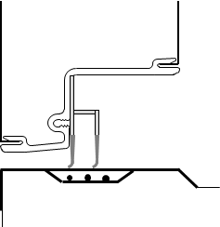
FASTEN THRESHOLD TO FLOOR PANEL
FLOOR BUIILD UP AT DOOR OPENING
SWEEP SHOULD CURL
SLIGHTLY AT THRESHOLD
SWEEP
ADJUSTMENT SCREWS
HEATER AT
FREEZER DOOR
SWEEP ADJUSTMENT SCREWS HEATER AT
FREEZER DOOR

SWEEP SHOULD CURL SLIGHTLY AT THRESHOLD

FASTEN THRESHOLD TO FLOOR PANEL

FIG. 38 – HEATED SWEEP DESIGN FOR OVERLAP FREEZER DOORS ON FLOOR PANEL
FIG. 39 – HEATED THRESHOLD DESIGN FOR FLUSH MOUNT FREEZER DOORS ON FLOOR PANEL

21

Threshold Installation (cont’d)

THRESHOLDS AT FREEZER DOORS WITH TILE FLOOR

DO NOT EXTEND TILE AND GROUT THROUGH THE FREEZER DOOR OPENING.

THRESHOLD TILE AND GROUT

SEPARATION STRIP BREAKER STRIP

Any tile and grout on the interior of the freezer must be completely separated and isolated from the tile and grout on the exterior of the freezer

Door Adjustments
- Check that door section is plumb and level

FIG. 40 –TILE AND GROUT AT FREEZER DOOR

- Check operation of door, adjust door section if necessary
- Check operation of latch and inside release
- Check magnetic gasket for proper seal
- Adjust sweep gasket down by loosening adjustment screws
- If sweep has more than slight curl, it must be trimmed to provide only a slight curl.

Finish Work after Panel Assembly
- Remove protective covering from panels, if applied
- Check that all cam locks are engaged.
- Install vinyl plugs in cam lock access holes.
- Install any trim that is supplied. See Installation drawing for trim type and location.

Penetrations
FIG. 41 – PENETRATIONS
CAM LOCK
ACCESS HOLE
6” RADIUS
PANEL JOINT
DO NOT CUT HOLES
WITHIN 6” OF CAM LOCK HOLE

In some instances it is necessary to make penetrations through the panels for electrical conduit or refrigeration lines.
Some areas of the walk-in panels contain working parts and should not be penetrated. Do not make penetrations within 6” of cam lock holes. Completely seal penetrations with sealant after electrical or refrigeration lines are installed through panels.
21
22

Concrete Floors and Tile and Grout

Gas emitted by curing concrete floors or tile grout will damage panel finishes. Adequate ventilation must be provided when the concrete floor or tile setting bed and grout have not properly cured. Leave all doors open for ventilation. If concrete or tile is to be installed after walk-in is assembled, protect the wall finish by applying a protective covering.

Clean Up
Clean panels of any dirt, metal shavings, sealants or other types of debris. Using a non-abrasive clean dry, cloth for dust removal is critical. Metal surfaces will scratch. The use of petroleum based cleaners such as WD-40 will loosen butyl and silicone residue for easier clean up. Use any cleaner with a silicate or phosphate base having a PH level of 11 or less in use. This category includes nearly any off the shelf products found in local stores such as “Tide”, “All” or any commercial dish washing detergent and hot water.

UNACCEPTABLE CLEANERS
Any chlorine based cleaner. Cleaners containing sodium hydroxide (i.e., caustic soda), potassium hydroxide, or ammonium hydroxide should not be used. This group includes nearly all “heavy duty” or “industrial strength” cleaners. Any cleaner showing a skull with crossed bones indicating it is poisonous will always contain caustic soda. Use of these types of cleaners can damage the walk-in surfaces or create toxic gases if improperly used. As these are poisonous, use in a food storage area is not advised.

VENTILATE THE AREA
While using any cleaners be sure the area is well ventilated. Personnel must take proper precautions to ensure the safety of crews cleaning and preparing the panels for the end user.

TOUCH UP PAINT
After panels have been wiped down, touch up paint will need to be applied on all scratches. The touch up paint is provided and will be located in the hardware box.

23

Thermometer Testing
To test for thermometer accuracy, use a mixture of crushed ice and water mixed to form a slush. Place the thermometer bulb in the mixture and check reading. The thermometer should read approximately 32°F. If not recalibrate per instructions. Digital thermometers cannot be field calibrated.

Thermometer testing is a required part of the installation to insure against miss-calibration that may have occurred during shipment.

Dial Thermometer Recalibration
If the dial does not read approximately 32°F, then remove the clear cover of the thermometer. The cover will screw off or pry off.

Care must be taken not to break or damage the cover.
To lower the reading, carefully hold the pointer, insert screwdriver in the pointer slot and slowly turn clockwise a small amount. Adjust to proper setting.

To raise the reading, carefully hold the pointer, insert screwdriver in the pointer slot and slowly turn counter clockwise a small amount. Adjust to proper setting.

Carefully reinstall the cover on the thermometer.

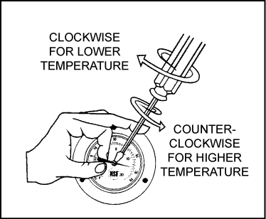

FIG. 42 – DIAL THERMOMETER RECALIBRATION

24

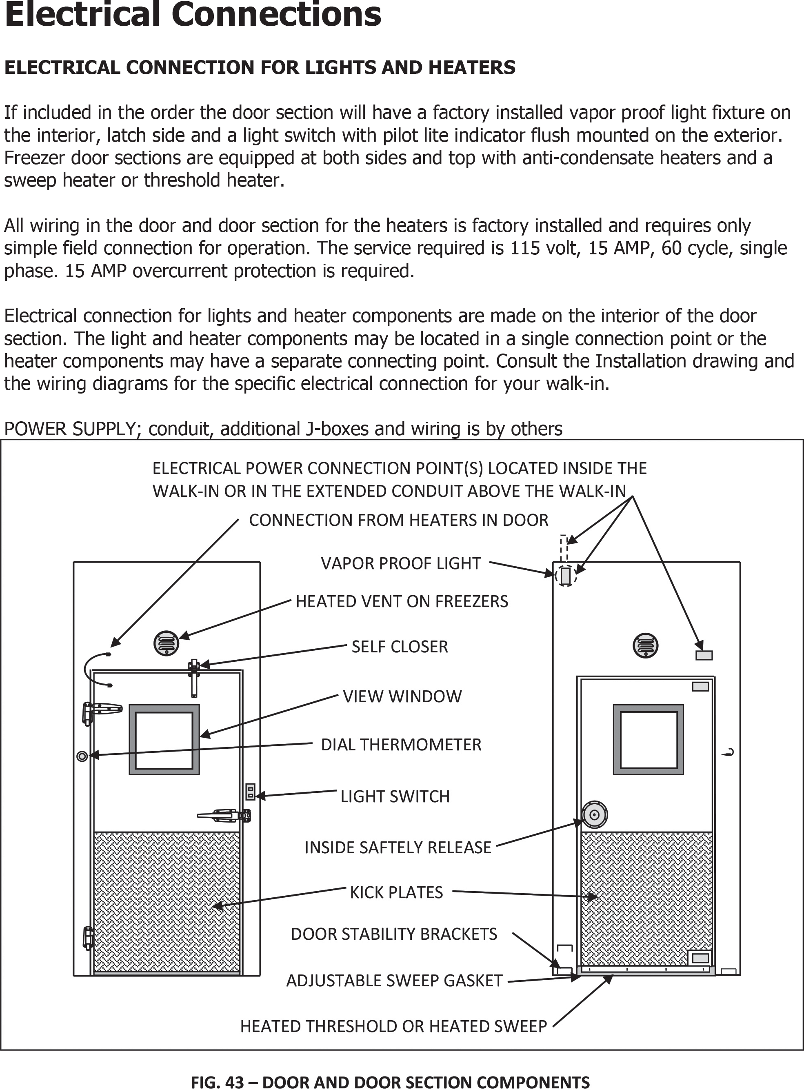

25

2-POINT POWER CONNECTION
CONDUIT AND J-BOX PLACEMENT
2-POINT CONNECTION

Electrical contractor to seal ceiling penetrations after installing field mounted conduit, place seal-off inside conduit prior to entering walk-in and fill with
waterproof compound.

HEATED VENT
½” CONDUIT
HEATER POWER
CONNECTION J-BOX OPEN TO INTERIOR
WHEN NOTED ON DRAWING
CONDUIT IS EXTENDED ABOVE DOOR SECTION FOR POWER CONNECTIONS
CONDUIT TO EXTERIOR
FOR WIRING HARNESS
CONDUIT FOR JAMB
HEATER CONNECTION
LIGHTING POWER
CONNECTION J-BOX OPEN TO INTERIOR
½” CONDUIT
HARNESS AND SWEEP
HEATER CONNECTION J-BOX OPEN TO INTERIOR
SWITCH J-BOX
OPEN TO EXTERIOR
½” CONDUIT
SWEEEP HEATER
CONNECTION J-BOX OPEN TO INTERIOR
DOOR FRAME
DOOR

FIG. 44 – CONDUIT AND J-BOX PLACEMENT 2-POINT CONNECTION
26

SINGLE POINT POWER CONNECTION

Electrical contractor to seal ceiling penetrations after installing field mounted conduit, place seal-off inside conduit prior to entering walk-in and fill with
waterproof compound.

HEATED VENT
½” CONDUIT
HEATER POWER
CONNECTION J-BOX OPEN TO INTERIOR
WHEN NOTED ON DRAWING
CONDUIT IS EXTENDED ABOVE DOOR SECTION FOR POWER CONNECTIONS
CONDUIT TO EXTERIOR
FOR WIRING HARNESS

CONDUIT FOR JAMB
HEATER CONNECTION
SINGLE POINT POWER
CONNECTION J-BOX OPEN TO INTERIOR WITH SURFACE MOUNTED 4 X 4 ON INTERIOR
HARNESS AND HEATED
WINDOW (OPT) CONNECTION J-BOX OPEN TO INTERIOR
½” CONDUIT
SWITCH J-BOX
OPEN TO EXTERIOR
DOOR FRAME
ALTERNATE THRESHOLD
HEATER J-BOX
DOOR

27
CONDUIT AND J-BOX PLACEMENT
SINGLE POINT CONNECTION
FIG. 45 – CONDUIT AND J-BOX PLACEMENT SINGLE POINT CONNECTION

ELECTRICAL CONDUIT AND J-BOXES HEATER CONNECTIONS

WARNING! – THE HEATER CABLE AND HEATED AIR VENT MUST NOT BE ENERGIZED PRIOR TO THE REFRIGERATION STARTUP. FAILURE TO DO SO MAY RESULT IN PREMATURE HEATER BURNOUT AND VOID THE HEATER WARRANTIES.

TO HEATED VENT

TO DOOR HARNESS

TO POWER CONNECTION J-BOX FOR SINGLE POINT CONNECTION

TO JAMB HEATER
HEATER J-BOX
TO DOOR HARNESS
TO SWEEP HEATER
CONNECTION J-BOX

HARNESS AND SWEEP HEATER CONNECTION J-BOX
TO HARNESS AND SWEEP
HEATER CONNECTION J-BOX
TO SWEEP HEATER

SWEEP HEATER J-BOX

FIG. 46 – HEATER CONNECTION J-BOXES 28

SWITCH LAYOUT
S4
POWER OUT
TO LIGHT
POWER INTO
SWITCH
S
ONE ENTRANCE WITH ONE SWITCH
USE SINGLE POLE SWITCH
SEE WIRING DIAGRAMS

S3
POWER OUT OF SECOND
3-WAYSWITCH TO LIGHT
TRAVELERS BETWEEN
SWITCHES
S3
POWER INTO FIRST
3-WAY SWITCH
TWO ENTRANCES WITH ONE
SWITCH EACH
USE TWO 3-WAY SWITCHES
SEE WIRING DIAGRAMS

29
S4
TRAVELERS BETWEEN
SWITCHES
MORE THAN TWO ENTRANCES
WITH ONE SWITCH EACH
POWER OUT OF LAST 3-WAY
SWITCH TO LIGHT
USE TWO 3-WAY SWITCHES AT FIRST
AND LAST LOCATION AND 4-WAY SWITCHES IN BETWEEN
SEE WIRING DIAGRAMS
S3
POWER INTO FIRST
3-WAY SWITCH
S3

FIG. 47 – SWITCH LAYOUT

Switch Wiring Diagrams

MARK LIGHT SWITCH POWER CONNECTION MARK HEATER POWER CONNECTION
POWER CONNECTION J-BOX
THESE LEADS FOR FIELD POWER CONNECTION

LIGHT BASE
IF REQUIRED

TO HEATER J-BOX FOR SINGLE POINT CONNECTION. HEATER WIRES IN SEPARATE J-BOX FOR DUAL POINT CONNECTION

½” CONDUIT

BLACK
GREEN

WHITE RED
SWITCH J-BOX

B1 WHITE

A1 RED

SINGLE POLE SWITCH
29
FIG. 48 – SINGLE POLE SWITCH WIRING 30

LIGHT SWITCH POWER CONNECTION
HEATER POWER CONNECTION POWER
CONNECTION J-BOX
THESE LEADS FOR FIELD POWER CONNECTION

TO HEATER J-BOX FOR SINGLE POINT CONNECTION. HEATER WIRES IN SEPARATE J-BOX FOR DUAL POINT CONNECTION
LIGHT BASE IF REQUIRED

½” CONDUIT

BATTERY BACK UP
MAGNETIC DOOR SENSOR
TEMPERATURE PROBE
BLACK WHITE

J-BOX

FRONT

GROUND TO J-BOX

GREEN

RED

VIEW
WEISS ALARM WITH BATTERY BACK UP
YELLOW

31

FIG. 49 – WEISS ALARM WITH BATTERY BACK UP SINGLE POLE SWITCH WIRING
30

MARK LIGHT SWITCH POWER CONNECTION HEATER POWER CONNECTION
POWER CONNECTION J-BOX
THESE LEADS FOR FIELD POWER CONNECTION

TO HEATER J-BOX FOR SINGLE POINT CONNECTION. HEATER WIRES IN SEPARATE J-BOX FOR DUAL POINT CONNECTION

LIGHT BASE
IF REQUIRED

½” CONDUIT

FRONT VIEW

GREE

GROUND TO J-BOX

BLACK

WHITE

75LC SWITCH J-BOX IP-1 J-BOX

RED

TEMPERATURE PROBE

75LC SWITCH

MAGNETIC DOOR SENSOR

IP-1

PANIC
PRESS TO KEEP LIGHTS ON WITH DOOR CLOSED PANIC ALARM II
PRESS & HOLD FOR 2 SEC.

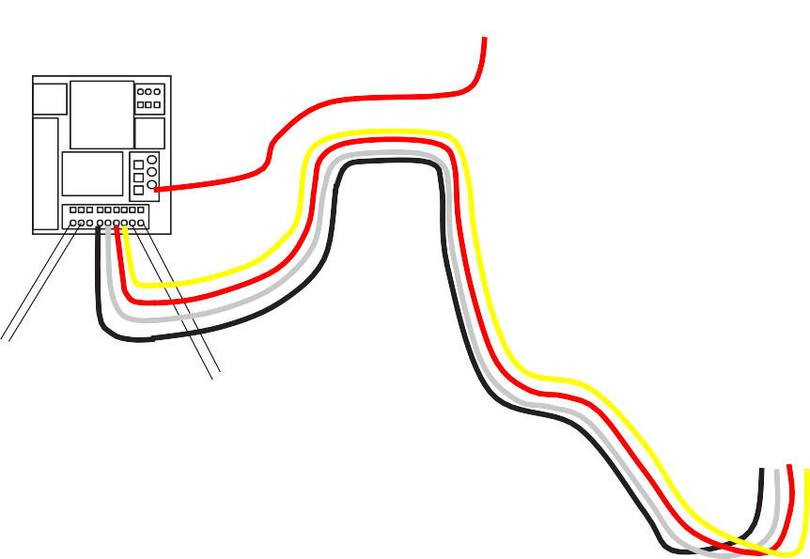BLACK YELLOW
RED

FIG. 50 – MODULARM 75LC WITH IP-1 SINGLE POLE SWITCH WIRING
FRONT VIEW
32
31

LIGHT SWITCH POWER CONNECTION HEATER POWER CONNECTION
THESE LEADS FOR FIELD POWER CONNECTION

POWER CONNECTION J-BOX

TO HEATER J-BOX FOR SINGLE POINT CONNECTION. HEATER WIRES IN SEPARATE J-BOX FOR DUAL POINT CONNECTION
LIGHT BASE IF REQUIRED

½” CONDUIT

GROUND TO J-BOX

GREEN

WHITE

RED
3
6

J-BOX

BLACK
1
2
4
5

FRONT VIEW

KASON PRESS SWITCH SINGLE POLE
33

FIG. 51 – KASON PRESS SWITCH SINGLE POLE SWITCH WIRING
32

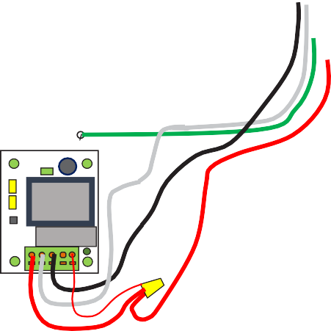LIGHT SWITCH POWER CONNECTION HEATER POWER CONNECTION
THESE LEADS FOR FIELD POWER CONNECTION

POWER CONNECTION J-BOX

TO HEATER J-BOX FOR SINGLE POINT CONNECTION. HEATER WIRES IN SEPARATE J-BOX FOR DUAL POINT CONNECTION

LIGHT BASE IF REQUIRED

½” CONDUIT

J-BOX

GROUND TO J-BOX

GREEN

WHITE

BLACK

RED
FRONT VIEW

KASON 1967-3 SWITCH SINGLE POLE

34

FIG. 52 – KASON 1967-3 SWITCH SINGLE POLE SWITCH WIRING
33

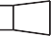POWER SUPPLY POWER SUPPLY, CONDUIT, WIRING AND JUNCTION

JUNCTION
BOXES FOR FIELD CONNECTION ARE BY OTHERS
JUNCTION

WHITE RED

GREEN

BLUE

BLUE

LIGHT BASE
BLACK
BLUE
BLUE
BLUE
LIGHT BASE

B1 WHITE
GREEN
WHITE
GREEN
WHITTE
RED

B1 WHITE

A1 & A2

3-WAY SWITCH
A1 & A2 BLUE
3-WAY SWITCH

BLUE
WALK-IN WITH 2 DOORS, 2 LIGHTS AND 2 – 3 WAY SWITCHES

FIG. 53 – 3-WAY SWITCH WIRING
34
35

POWER
JUNCTION
POWER SUPPLY, CONDUIT, WIRING AND JUNCTION BOXES FOR FIELD CONNECTION ARE BY OTHERS
JUNCTION

FRONT VIEW

MD-1

GREEN
GROUND TO J-BOX

FRONT VIEW
TEMPERATUR

75LC

MAGNETIC

E PROBE
MAGNETIC
DOOR SENSOR
PRESS TO KEEP LIGHTS ON
WITH DOOR CLOSED PANIC ALARM II
PRESS & HOLD FOR 2 SEC.

75LC IN UNITS WITH 2 DOORS MUST BE INSTALLED WITH MD-1 AS ONLY 1 DOOR HAS A SWITCH
DOOR

PANIC

IP-1

BLACK
YELLOW RED
WHITE

IP-1

BLACK

YELLOW

RED WHITE

FIG. 54 – 75LC IN UNIITS WITH 2 DOORS SWITCH WIRING
35
FRONT VIEW
36

POWER SUPPLY
POWER SUPPLY, CONDUIT, WIRING AND JUNCTION BOXES FOR FIELD CONNECTION ARE BY OTHERS
JUNCTION BOX JUNCTION
BOX

WHITE RED
BLACK GREEN

BLUE

BLUE

LIGHT BASE
WHITE
BLACK
BLUE
BLUE
RED
BLUE
BLACK
LIGHT BASE

GROUND
GREEN
GREEN
WHITTE
TO J-BOX
3
6
3
6
GROUND TO J-BOX

BLAC
1
2
4
5
1
2
4
5

FRONT
KASON PRESS SWITCH

FRONT

KASON PRESS SWITCH

BLUE
WALK-IN WITH 2 DOORS, 2 LIGHTS AND 2 – 3 WAY SWITCHES PRESS

FIG. 55 – KASON PRESS 3-WAY SWITCH WIRING
36
37

POWER SUPPLY
POWER SUPPLY, CONDUIT, WIRING AND JUNCTION BOXES FOR FIELD CONNECTION ARE BY OTHERS
JUNCTION BOX JUNCTION

WHITE RED
BLACK GREEN

BLUE

BLUE

LIGHT BASE
WHITE
BLACK
BLUE
BLUE
RED
BLUE
BLACK
LIGHT BASE

GROUND TO J-BOX
GREEN
3
6
GREEN
WHITTE
3
6
GROUND TO J-BOX

BLAC
1
2
4
5
1
2
4
5

FRONT VIEW
KASON PRESS SWITCH

FRONT VIEW

KASON PRESS SWITCH

BLUE
WALK-IN WITH 2 DOORS, 2 LIGHTS AND 2 – 3 WAY SWITCHES PRESS

FIG. 56 – KASON PRESS 3-WAY SWITCH WIRING
37
38

POWER SUPPLY
POWER SUPPLY, CONDUIT, WIRING AND JUNCTION BOXES FOR FIELD CONNECTION ARE BY OTHERS
JUNCTION BOX JUNCTION

WHITE RED
BLACK GREEN

BLUE

BLUE

LIGHT BASE
BLACK
BLUE
BLUE
RED
BLUE
BLACK
LIGHT BASE

GROUND TO J-BOX
GREEN
WHITE
GREEN
WHITTE

GROUND TO J-BOX
2
3
5
6

FRONT VIEW
KASON 1967-3 SWITCH AS 3-WAY
FRONT VIEW
1
4
KASON PRESS SWITCH

BLUE
WALK-IN WITH 2 DOORS, 2 LIGHTS AND 2 – 1967-3 AS 3 WAY SWITCH AND 3 WAY PRESS SWITCH

FIG. 57 – KASON 1967-3 WIRING AS 3-WAY
38
39

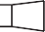POWER SUPPLY POWER SUPPLY, CONDUIT, WIRING AND

JUNCTION BOX
JUNCTION BOXES FOR FIELD CONNECTION ARE BY
JUNCTION BOX

WHITE RED

GREEN

BLUE

BLUE

BLUE

LIGHT BASE
BLUE
BLUE

LIGHT BASE
BLUE

LIGHT BASE
BLACK
BLUE
GREEN
BLUE
RED
BLUE
BLUE TRAVELERS WRAPPED IN PAIRS

B1 WHITE
GREEN
WHITE
BLUE
BLUE
GREEN
WHITTE

B1 WHITE

A1 & A2 BLUE

3-WAY SWITCH

4-WAY SWITCH
A1 & A2 BLUE

3-WAY SWITCH

WALK-IN WITH AT LEAST 3 DOORS, 3 LIGHTS AND 2 – 3 WAY SWITCHES AND 1 OR MORE 4-WAY SWITCHES

FIG. 58 – SWITCH WIRING 4-WAY
39
40

POWER SUPPLY
POWER SUPPLY, CONDUIT, WIRING AND JUNCTION BOXES FOR FIELD CONNECTION ARE BY OTHERS
JUNCTION BOX
JUNCTION BOX

JUNCTION BOX

FRONT VIEW

MD-

GREEN
GROUND TO J-BOX

FRONT VIEW
TEMPERATURE

75LC
RED

MAGNETIC DOOR

MAGNETIC DOOR

PROBE MAGNETIC
DOOR SENSOR
PRESS TO KEEP LIGHTS ON WITH DOOR CLOSED PANIC ALARM II
PRESS & HOLD FOR 2 SEC.

PANIC

FRONT VIEW

IP-1

YELLOW RED
WHITE
BLACK

IP-1
75LC IN UNITS WITH 3 DOORS
MUST BE INSTALLED WITH MD-1 AS ONLY 1 DOOR HAS A SWITCH

BLACK

YELLOW
RED WHITE

IP-1

BLACK
YELLOW

RED WHITE

FIG. 59 – 75LC WIRING at 3 DOORS
40
41

POWER SUPPLY
POWER SUPPLY, CONDUIT, WIRING AND JUNCTION BOXES FOR FIELD CONNECTION ARE BY OTHERS
JUNCTION BOX
JUNCTION BOX

JUNCTION BOX

FRONT VIEW

MD-

GREEN
GROUND TO J-BOX

FRONT VIEW
TEMPERATURE

75LC
RED

MAGNETIC DOOR

MAGNETIC DOOR

PROBE MAGNETIC
DOOR SENSOR
PRESS TO KEEP LIGHTS ON WITH DOOR CLOSED PANIC ALARM II
PRESS & HOLD FOR 2 SEC.

PANIC

FRONT VIEW

IP-1

YELLOW RED
WHITE
BLACK

IP-1
75LC IN UNITS WITH 3 DOORS
MUST BE INSTALLED WITH MD-1 AS ONLY 1 DOOR HAS A SWITCH

BLACK

YELLOW
RED WHITE

IP-1

BLACK
YELLOW

RED WHITE

FIG. 59 – 75LC WIRING at 3 DOORS
40
42

POWER SUPPLY POWER SUPPLY, CONDUIT, WIRING AND JUNCTION

JUNCTION BOX
BOXES FOR FIELD CONNECTION ARE BY OTHERS
JUNCTION BOX

WHITE RED
RED GREEN

BROWN

BLUE

LIGHT BASE
ORANGE
YELLOW
BLUE
BLUE

LIGHT BASE
RED

LIGHT
BASE
N W
O R B
RED
BLACK
GREEN
RED
BROW
TRAVELERS WRAPPED IN PAIRS

FRONT VIEW
GREEN
WHITE
ORANG
WHITTE

FRONT VIEW
YELLOW

FRONT VIEW
GREEN

GROUND TO J-BOX

GROUND TO J-BOX

GROUND TO J-BOX
2
3
5
6
3
6
2
3
5
6

KASON PRESS SWITCH
1
4
1
2
4
5
1
4

KASON PRESS SWITCH

WALK-IN WITH AT LEAST 3 DOORS, 3 LIGHTS AND 2 – 3 WAY PRESS SWITCHES AND 1 OR MORE 4-WAY PRESS SWITCHES

FIG. 60 – KASON PRESS SWITCH WIRING 4-WAY
41
KASON PRESS SWITCH
43

POWER SUPPLY POWER SUPPLY, CONDUIT, WIRING AND JUNCTION

JUNCTION BOX
BOXES FOR FIELD CONNECTION ARE BY OTHERS
JUNCTION BOX

WHITE RED
RED GREEN

BROWN

BLUE

LIGHT BASE
ORANGE
YELLOW
BLUE
BLUE

LIGHT BASE
RED

LIGHT BASE
N W
O R B
RED
BLACK
GREEN
WHITTE
RED
BROW
TRAVELERS WRAPPED IN PAIRS

FRONT
GREEN
WHITE
ORANG
FRONT
FRONT

GROUND TO J-BOX
YELLOW
GREEN

GROUND TO J-BOX

GROUND TO J-BOX
2
3
6
2
3
5
6

KASON 1967-3 SWITCH AS 3-WAY
1
4
5
1
4
KASON PRESS SWITCH
KASON PRESS SWITCH

WALK-IN WITH AT LEAST 3 DOORS, 3 LIGHTS AND 2 – 3 WAY PRESS SWITCHES AND 1 OR MORE 4-WAY PRESS SWITCHES

FIG. 61 – KASON PRESS SWITCH WIRING 4-WAY
42
44

POWER SUPPLY

AIR CURTAIN JUNCTION BOX

CLC212-NC OR OTHER SWITCH

MAGNETIC DOOR SENSOR

GROUND TO J-BOX

GREEN

GROUND TO J-BOX

LIGHT SWITCH WITH FAN/AIR CURTAIN SWITCH

FRONT VIEW
TEMPERATURE PROBE
75LC OR OTHER SWITCH
MAGNETIC DOOR SENSOR

FIG. 62 – MULTI SENSOR SWITCH WIRING
43
45

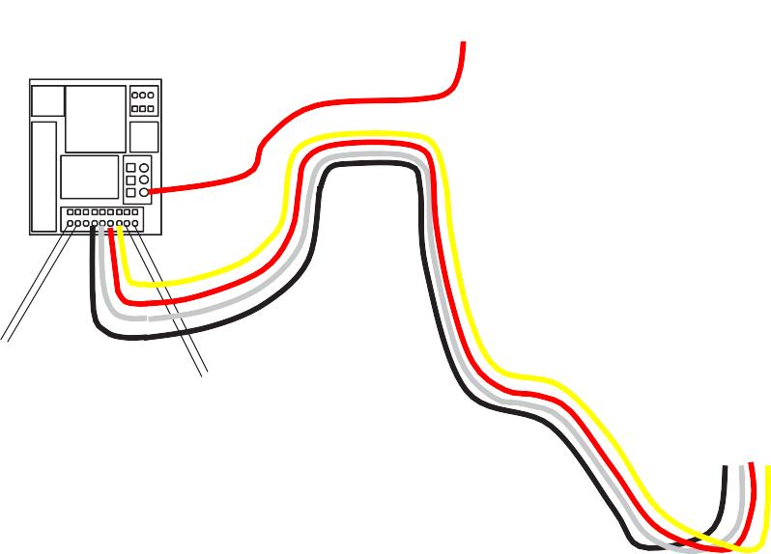MARK LIGHT SWITCH POWER HEATER POWER
POWER CONNECTION J-
LEADS TO HEATER J-BOX FOR SINGLE POINT CONNECTION. HEATER WIRES IN SEPARATE J-BOX FOR DUAL POINT

MARK THESE LEADS FOR CONNECTION TO 75LC WIRELESS BLACK LEAD
THESE LEADS FOR FIELD POWER

½” CONDUIT

LIGHT BASE IF
REQUIRED

FROM ONE 75LC ONLY ALL OTHERS
POWER SUPPLY, CONDUIT, WIRING, JUNCTION BOXES FOR FIELD CONNECTION AND 75LC WIRELESS ARE BY OTHERS

75LC-1
R
X
L
H
S
X
R
TX
D
4 WIRES
75LC-2, 3 & 4
3 WIRES
X
R
X
R
X
T
TX
TX

ORANGE BROWN BLUE BLACK

GREEN

FRONT VIEW

GROUND TO J-BOX

BLACK

WHITE
CONNECTIONS TO 75LC

75LC SWITCH J-BOX IP-1 J-BOX

RED

TEMPERATURE PROBE

75LC
MAGNETIC DOOR SENSOR

IP-1

PANIC
PRESS TO KEEP LIGHTS ON WITH DOOR CLOSED PANIC ALARM II
PRESS & HOLD FOR 2 SEC.

BLACK

WHITE RED
YELLOW

FRONT VIEW

FIG. 63 – 75LC/IP-1 FOR 75LC WIRELESS WIRING
44
46

POWER SUPPLY
POWER SUPPLY, CONDUIT, WIRING AND JUNCTION BOXES FOR FIELD CONNECTION ARE BY

MARK THESE LEADS FOR CONNECTION TO
JUNCTION BOX
JUNCTION BOX

BLACK LEAD FROM ONE 75LC ONLY ALL OTHERS HAVE ONLY 3 WIRES
ORANGE BROWN BLUE BLACK

75LC-1
4 WIRES
R
X
L
H S
TX

CONNECTIONS TO 75LC
X
R
TX

75LC-2, 3 & 4
X
R
TX
D PR
- 3 WIRES
X
X
T R

FRONT VIEW

MD-
POWER SUPPLY, CONDUIT, WIRING, JUNCTION BOXES FOR FIELD CONNECTION AND 75LC WIRELESS ARE BY OTHERS

GREE
GROUND TO J-BOX

FRONT VIEW
TEMPERATURE

75LC

MAGNETIC

PROBE
MAGNETIC
DOOR
DOOR

PRESS TO KEEP LIGHTS ON WITH DOOR CLOSED PANIC ALARM II
PRESS & HOLD FOR 2 SEC.

PANIC

FRONT VIEW

IP-1

BLACK
YELLOW

RED WHITE
75LC IN UNITS WITH 2 DOORS MUST BE INSTALLED WITH MD-1 AS ONLY 1 DOOR HAS A SWITCH

IP-1
YELLOW

BLACK

RED WHITE

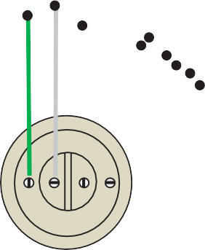FIG. 64 – 75LC/IP-1/MD-1 FOR 75LC WIRELESS WIRING AT 2 DOORS
45
47

Membrane Roof Installation
ROOF INSTALLATION – TAPERED ROOF SYSTEM

INSTALL TAPERED FOAM BLOCKS. THEY ARE TAPERED ON TOP AND WILL PROVIDE A CONTINUOUS ROOF SLOPE

CUT OFF EXCESS TAPERED FOAM ALIGN WITH EDGE OF WALK-IN AND TIGHT TO BUILDING

APPLY DURO-LAST DURA BLUE SEPARATION SLIP SHEET OVER ALL TAPERED FOAM. FASTEN AS NECESSARY TO HOLD IN PLACE – 6” OVERLAP AT ANY JOINTS

FIG. 65 TAPERED ROOF SYSTEM; TAPERED BLOCKS AND DURO-LAST DURO BLUE SEPARATION SLIP SHEET
Locate tallest tapered blocks and install on top of walk-in ceiling panels and against building wall.

If Walk-in is free standing and not against a building wall, align the tall edge of the tapered block with the edge of the walk-in ceiling panel.

2” SPACE BETWEEN WALK-IN AND BUILDING WALL
FIG. 66 ROOF AT BUILDING WALL
If distance between walk-in and building wall exceeds 4”, support angle must be installed between walk-in and building wall to support foam blocks. (Support angle not provided)

Install tapered blocks in succession from high side to low side. If tapered blocks extend beyond walk-in tops, use hand saw to cut off excess.

Install Duro-Last Duro Blue separation slip sheet to completely cover all tapered blocks and exposed edges. Fasten as necessary to hold in place. If roofing board is included, install 4’ X 8’ boards in alternating pattern over the slip sheet and fasten as necessary to hold in place.

Multi-length fasteners are supplied to fasten through the membrane flap, roofing board (if included), slip sheet, tapered blocks and into the top skin of the ceiling panels.
46
48

PREPARATION
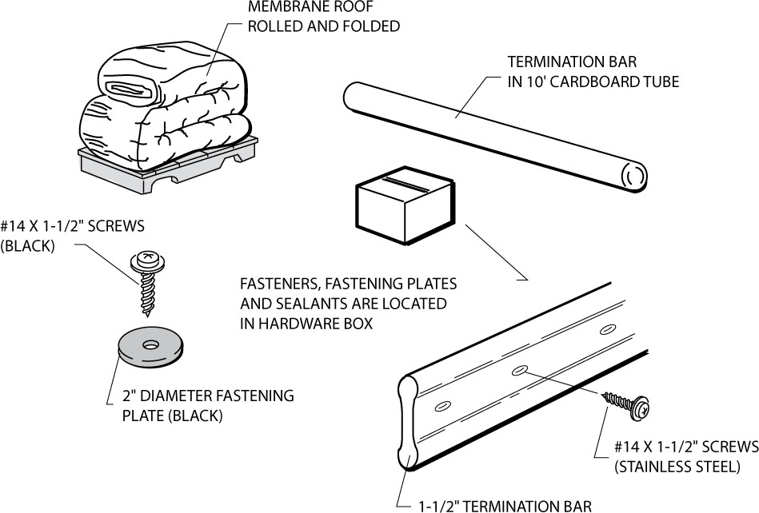Locate the parts required for the installation of the membrane roof. The membrane roof is shipped rolled and folded. The termination bar and any roof trim required are shipped in 6” diameter by 10’ long cardboard tubes. A hardware box containing screws, fastening plates and sealant is included.
FIG. 67 MEMBRANE ROOF PARTS
Check the roof of the walk-in unit and remove any foreign matter. Seal all protruding rough edges and screw heads, rivets, etc. with tape or sealant. This will prevent any chance of penetrating or wearing a hole in the membrane roof cap.

Remove all debris and cover rough edges with tape or sealant.
PREPARE TOP PANELS

VERIFY MEMBRANE SIZE
Verify the overall width and length. The membrane should overhang the top edge of the wall panel by 2” on all exposed sides of the walk-in unit. And extend at least 8” up on adjacent building walls.

POSITION MEMBRANE
The smooth (shiny) finish surface of the membrane is the exposed (up) side. The 3” fastening
tabs are on the bottom side of the membrane.
47

49

FASTEN FIRST TAB

Align the roof membrane so that the tabs are parallel with the high side of the tapered roof system. Locate the reverse tab and fasten using fastener and fastening plate as shown below.

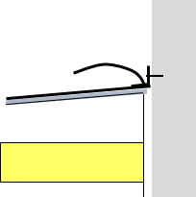FASTEN REVERSE FLAP TO BUILDING WALL
ROLL MEMBRANE UP WALL AND FASTEN WITH TERMINATION BAR AND SEAL

FASTEN REVERSE TAB TO TOP EDGE OF ROOF

ROLL MEMBRANE DOWN AND FASTEN TO TOP OF WALL WITH TERMINATION BAR AND SEAL

FIG. 68 FASTENING AT FREE STANDING WALK-IN FIG. 69 FASTENING AT ADJACENT BUILDING

Locate the reverse tab on the edge of the high side of the tapered roof. Start in the middle of the tab and work toward the edges placing the screws and plates 6” on center. Pull membrane toward edges to remove slack. Unroll roof to the next tab and continue stretching and fastening in the same manner. The variable length screws should penetrate the top metal skin of the walk-in ceiling panel.
Locate the reverse tab on the building wall. Start in the middle of the tab and work toward the edges placing the screws and plates 6” on center. Pull membrane toward edges to remove slack. Make sure at least 8” of material is up the wall for proper termination. Unroll roof to the next tab and continue stretching and fastening in the same manner. The variable length screws should penetrate the top metal skin of the walk-in ceiling panel.

The screw length will vary. Install the short screws at the low side and increasingly longer screws toward the high side. Extra care should be taken to only penetrate the top metal skin of the walk in ceiling panel. Do not penetrate the interior metal skin.

CONTINUE FASTENING

Unroll roof cap membrane to next tab and repeat the screw and fastening plate pattern. Always pull slack out of membrane before starting a row of fasteners. Use of vice grips is ideal to keep material taut.
48
50

MEMBRANE ROOF TAB SPACING AND FASTENER SPACING ARE BASED ON WIND LOAD. THE MEMBRANE ROOF TAB SPACING AND FASTENER SPACING ARE IN ACCORDANCE WITH THE FOLLOWING CHART:

WIND ZONE | TAB SPACING | FASTENER SPACING
110 MPH | 60" | 6”
115 MPH | 60" | 6”
120 MPH | 60” | 6”
130 MPH | 60” | 6”
140 MPH | 28” | 6”
150 MPH | 28” | 6”
160 MPH | 28” | 6”
170 MPH | 28” | 6”
180 MPH | 28” | 6”
190 MPH | 28" | 6"
200 MPH | 24" | 6"
THIS CHART IS BASED ON ASCE7-5 AND ASCE7-10 FOR EXPOSURES B, C OR D.

FASTENER
SPACING
TAB SPACING
FASTENERS WITH GALVANIZED
WASHERS THROUGH MEMBRANE FLAP, SLIP SHEET, TAPERED FOAM AND INTO TOP SKIN OF PANEL
DURO-LAST DURA BLUE SEPARATION
SLIP SHEET COVERING ALL EXPOSED TAPERED FOAM. IF ROOFING BOARD IS USED INSTALL IN ALTERNATING PATTERN OVER SLIP SHEET
TOP PANELS
TAPERED FOAM BUILDING WALL
MEMBRANE ROOF

FIG. 70 MEMBRANE ROOF TAB AND FASTENER SPACING FASTENING
49

51

FASTEN TERMINATION BAR
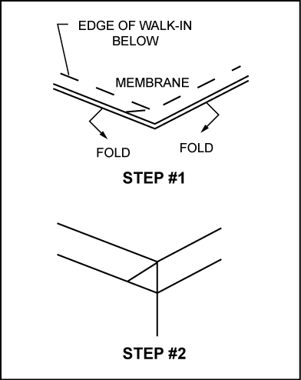
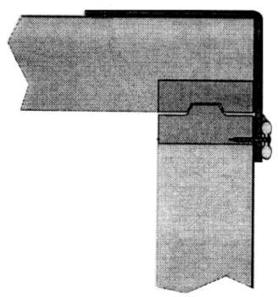FOLD CORNERS
.
After all fastening tabs have been secured, fold corners as shown in step #1 and #2 and install termination bar around perimeter of walk-in unit. Use 1-1/2” stainless steel screws spaced 6” on center.

Trim membrane before applying sealant to top and bottom edge of termination bar. Protect the metal panel skin when trimming under termination bar.

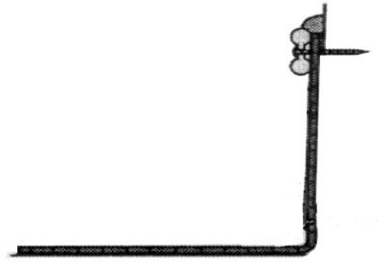Customer is responsible for providing flashing to protect membrane edge attached to adjacent building.

FIG. 71 INSTALLATION OF TERMINATION BAR
52
50

Maintenance and Housekeeping Recommendations
51

Walk-in floors can become slippery and hazardous if allowed to become wet, greasy or icy. Follow maintenance and housekeeping recommendations outlined below.

  - Inspect the condition of abrasive coated anti-skid strips (if included) on ramps monthly. Replace or add additional strips when necessary. Additional strips are available from the factory.

  - Keep all walkway surfaces clean and free of spilled liquids and food particles. This includes the floor surface, floor racks and diamond tread plate.

  - Inspect refrigeration equipment frequently for proper functioning of evaporators, drain pan heaters, defrost controls and drains line heaters.

  - Condensate water must never be permitted to drip on the walk-in floor. Refer to refrigeration system instructions for proper condensate drain line installation.

  - If entry doors are to be held open for periods longer than 5 minutes, a vinyl strip curtain should be used. When freezer doors are opened for extended periods of time, frost can form on the ceiling and floor due to the excessive condensation from warm moist air inside the walk-in. This can result in the formation of an ice film on ceiling, wall and floor surfaces in freezers.

  - Inspect the door hardware and sweep gasket monthly for ease of operation. Door hardware is self-lubricating and does not require periodic lubrication. Sweep gasket must be adjusted to allow free movement and proper seal. Any damaged hardware should be replaced immediately to prevent permanent damage to door.

  - Frost or condensation appearing around the door jamb or heated pressure relief vent indicates that the electric heater is inoperable. Check power supply (must be 120V) and electrical connections. Replace heaters if necessary.

  - All metal surfaces, magnetic door gasket and door sweep gasket should be cleaned frequently with mild detergent and hot water. Remove all soap film and dry thoroughly with a clean cloth. Never use high pressure hose or large amounts of water to clean the walk-in.

53

0-E VE R ID GE ®
Every step of the way ®

( CROWNTONK ( 1c s- ( LOTEMP DOORS- ( P REP RITE- ( THERMAL RITE"

Proud to be family-owned.

Walk- In Coolers/ Freeze rs · Restoration & Replacement Doors · Cook - Ch ill Specialt y So lu tions · Parts , Service & Warr anty • Cons tru ct io n Se rvices
15600 37th Av e N • Suite 100 • PILJm o u t h, M in nes ot a 55446 • 888 - 227 - 1629 • w w w .Everid ge .com • info @e ve ridg e.c o m

